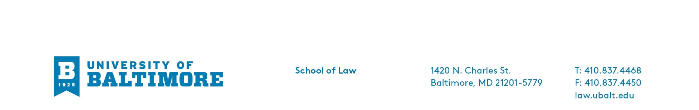
2020 Moot Court Competition

Starting this year, the Annual Byron Warnken Moot Court Competition will be held the first week of the fall semester. Interested students may participate in one of two ways in seeking a position on the six highly competitive moot court teams that the law school fields each year. First, 1L day and evening students may be invited to apply based on the recommendation of their professors in their Introduction to Advocacy courses; each ITA section professor will identify two students who exhibit appitude for oral advocacy and brief writing based on selection criteria created by the Moot Court Board. If invited, and to recognize their stellar work in ITA, students will compete in the Moot Court competion by arguing a fictional case; they will not have to write and submit a trial memo. Second, any student may apply to participate in the Moot Court competition. To do this, a student will complete a short written trial brief based on the hypothetical case and a closed universe of cases. The problem is released at the beginning of June and students may complete it at any time prior to the deadline set in early August. (It is estimated that the exercise of writing the brief should not take longer than a week.) Every student who is invited or who applies will then compete in the Moot Court Competition and argue their case before a judge or a panel of judges. Those with the highest scores and who meet the required GPA criteria are selected to be on a team. If chosen for a team, two academic credit hours may be awarded in the semester that a team’s competition is held. (Students should plan their fall schedules, keeping in mind that 16 credits are the maximum number of credits that can be earned in a semester.) Any questions concerning the Moot Court Competition should be directed to the 2020-21 President Kevin Reinoso.

The fall Moot Court Competition concludes with a showcase of two or more of the best competitors arguing before the entire law school in a “Finale Round” and will be judged by distinguished alumni judges and practitioners. Awards may be given for best overall oral argument competitor, best brief, and best oral advocates. A celebratory reception recognizing everyone’s participation concludes the night.

